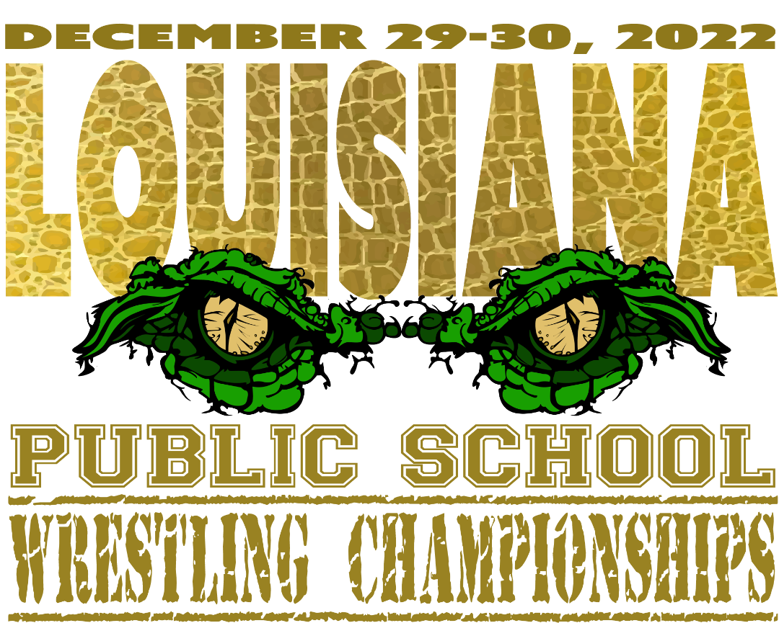
Coaches,
I am excited to announce for the first time in our great sport, Louisiana will have a Public-School Championships. I hope that you will consider joining us on this momentous occasion. For years we have acknowledged the highest placing Public School at the LHSAA State Championships. Well, now there will be no doubts on which Public School is truly the best.
East Ascension will host the tournament at Lamar Dixon on December 29 and 30, 2022. We have had 40 schools commit to this point. I will list the information for the tournament below. Feel free to email me Patrick.mahoney@apsb.org or call me at 225-954-7804. I hope I see you and your team there!!

WHAT: 2022 Public School Wrestling Championships
ONE DIVISION, ONE CHAMPION, NO EXCUSES!!!
WHERE: Lamar Dixon Expo Center, 9039 South St Landry Avenue, Gonzales, Louisiana 70737
WHEN: December 29 and 30, 2022
ENTRY FEE: $20.00 per wrestler
GATE: $15.00 / day or $20.00 for a tournament pass
RULES: NFHS Rules
MATS: 8
AWARDS: Medals for the top 6 placers in each weight class
Team Trophies for the top 3 placing teams
OW Awards Lower Weights (103-145) and Upper Weights (152-285)
Individual Weight Class Winners will receive the following:
Championship Hoodie
Custom Singlet
Custom Sublimated Bag
Tournament t-shirts and sweatshirts will be available online and at the event.

