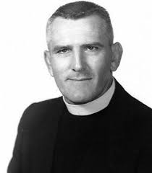
Brother Melchior Open

Date: Saturday, November 11th, 2023
Format:
*All Rosters must be submitted through Track Wrestling via link sent out.
- All Wrestling will be conducted on the main gymnasium floor
- Weigh ins for JV/Varsity will be conducted in the wrestling room on the 2nd floor.

JV/Varisty Fee: $20.00 per wrestler
Junior High Fee: $20.00 per wrestler (Pricing will be $10.00 Dollars for teams over 10)
Line-Ups: Please enter line-ups and seeding information on track wrestling by 7:00 p.m. Thursday, November 9th, 2023.
  - Please Enter weights on track wrestling Preregistration link no later than 7pm on Thursday.

Junior High Start and End Times: 7:00am-10am.
JV/Varisty Weigh In: Varsity Weigh ins will begin at 9:00am in the wrestling room. Varsity start time will begin at 10:30am **Junior high will follow under satellite weigh ins. (Coaches please register wrestlers via track wrestling)
Schools
Participating: Rummel, Brusly, Brother Martin, St. Paul, Holy Cross, Jesuit, Riverdale, Grace King, Teurlings Catholic, Catholic High School, John Ehret, Destrehan, Challemette, St. Thomas Moore, Belle Chasse

Scoring: No Teams Scores Will Be Kept

Awards: 1st – 3rd Place Individual Medals will be given out for JV and Varsity

School Address: 5500 Paris Avenue
New Orleans, Louisiana 70122

We are looking forward to you and your team being a part of our tournament.
George Benoit
Cell: (504)715-6874
gbenoit@holycrosstigers.com

